**MACHINE SHOP**

**SYLLABUS**

Machines and machine tools, Grinders etc; cutting tools and operations; exercises involving awareness.

**SAFETY PRECAUTIONS**

* Safety glasses with side shields or goggles are to be worn at all times while in the shop. Bring your own glasses.
* No loose fitting clothing allowed when working in the shop.
* No open toe shoes or sandals allowed in shop.
* Students must have prints or drawings of parts with dimensions, hole locations, thread sizes, and other machining information prior to machining.
* Students must clean and return all tools to proper location when finished.
* No tools are to be removed from shop without authorization.
* Floor area where work was done must be swept after every use.
* Never enter the student shop through the main shop. If the door is locked, use your key. If you don’t have a key you are not authorized to use the shop. Always shut shop door when you leave if no one else is in the shop.
* Never attempt to use equipment you have not received training on.
* Report any broken tools or machines immediately to main shop.

**MACHINE SHOP**

**INTRODUCTION**

A **machine shop** is a room, building, or company where [machining](https://en.wikipedia.org/wiki/Machining) is done. In a machine shop, [machinists](https://en.wikipedia.org/wiki/Machinist) use [machine-tools](https://en.wikipedia.org/wiki/Machine_tool) and [cutting-tools](https://en.wikipedia.org/wiki/Cutting_tool_(machining)) to make parts of [metal](https://en.wikipedia.org/wiki/Metal) or [plastic](https://en.wikipedia.org/wiki/Plastic) (but sometimes of other materials such as [glass](https://en.wikipedia.org/wiki/Glass) or [wood](https://en.wikipedia.org/wiki/Wood)). A machine shop can be a [small business](https://en.wikipedia.org/wiki/Small_business) (such as a [job shop](https://en.wikipedia.org/wiki/Job_shop)) or a portion of a [factory](https://en.wikipedia.org/wiki/Factory), whether a [tool room](https://en.wikipedia.org/wiki/Toolroom) or a production area for [manufacturing](https://en.wikipedia.org/wiki/Manufacturing). The parts produced can be the [end product](https://en.wikipedia.org/wiki/Product_(business)) of the factory, to be sold to customers in the [machine industry](https://en.wikipedia.org/wiki/Machine_industry), the [car industry](https://en.wikipedia.org/wiki/Car_industry), the [aircraft industry](https://en.wikipedia.org/wiki/Aircraft_industry), or others. In other cases, companies in those fields have their own machine shops.

Machine shop is a place in which metal parts are cut to the required size and put together form mechanical units or machines. The machines so made are to be used directly or indirectly in the production of necessities and luxuries of civilization. Machine shop is the base of all mechanical production.

**MACHINES**

A [machine](https://en.wikipedia.org/wiki/Machine) is a [tool](https://en.wikipedia.org/wiki/Tool) containing one or more parts that uses [energy](https://en.wikipedia.org/wiki/Energy) to perform an intended action. Machines are usually [powered](https://en.wikipedia.org/wiki/Work_(physics)) by mechanical, chemical, thermal, or electrical means, and are often [motorized](https://en.wikipedia.org/wiki/Engine). Historically, a [power tool](https://en.wikipedia.org/wiki/Power_tool) also required moving parts to classify as a machine. However, the advent of [electronics](https://en.wikipedia.org/wiki/Electronics) has led to the development of power tools without moving parts that are considered machines.

**MACHINING**

[Machining](https://en.wikipedia.org/wiki/Machining) is any of various processes in which a piece of raw material is cut into a desired final shape and size by a controlled material-removal process. The many processes that have this common theme, controlled material removal, are today collectively known as subtractive manufacturing, in distinction from processes of controlled material addition, which are known as additive manufacturing. Exactly what the "controlled" part of the definition implies can vary, but it almost always implies the use of machine tools (in addition to just power tools and hand tools).

**TYPES OF MACHINES USED IN MACHINE SHOP**

* LATHE MACHINE
* MILLING MACHINE
* POWER HACKSAW MACHINE
* DRILLING MACHINE
* SURFACE GRINDER
* TOOL GRINDER

**LATHE MACHINE**

**INTRODUCTION**

Lathe is one of the most versatile and widely used machine tools all over the world. It is commonly known as the mother of all other machine tool. The main function of a lathe is to remove metal from a job to give it the required shape and size. The job is secure1y and rigid1y held in the chuck or in between centers on the lathe machine and then turn it against a single point cutting tool which wi1l remove meta1 from the job in the form of chips. Fig. 21.1 shows the working principle of lathe. An engine lathe is the most basic and simplest form of the lathe. It derives its name from the early lathes, which obtained their power from engines. Besides the simple turning operation as described above, lathe can be used to carry out other operations also, such as drilling, reaming, boring, taper turning, knurling, screw- thread cutting, grinding etc

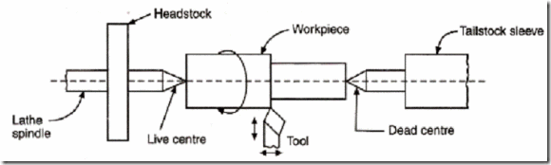

**Working principle of Lathe Machine**

**TYPES OF LATHE**

Lathes are manufactured in a variety of types and sizes, from very small bench lathes used for precision work to huge lathes used for turning large steel shafts. But the principle of operation and function of all types of lathes is same. The different types of lathes are:

1. Speed Lathe
2. Centre or Engine Lathe
3. Bench Lathe
4. Tool Room Lathe
5. Capstan and Turret Lathe
6. Automatic Lathe

**SPEED LATHE**

Speed lathe is simplest of all types of lathes in construction and operation. The important parts of speed lathe are following-

(1) Bed

(2) Headstock

(3) Tailstock, and

(4) Tool post mounted on an adjustable slide.

It has no feed box, 1eadscrew or conventional type of carriage. The tool is mounted on the adjustable slide and is fed into the work by hand contro1. The speed lathe finds applications where cutting force is least such as in wood working, spinning, centering, polishing, winding, buffing etc. This lathe has been so named because of the very high speed of the headstock spindle.

**CENTRE LATHE OR ENGINE LATHE**

The term “engine” is associated with this lathe due to the fact that in the very early days of its development it was driven by steam engine. This lathe is the important member of the lathe family and is the most widely used. Similar to the speed lathe, the engine lathe has all the basic parts, e.g., bed, headstock, and tailstock. But its headstock is much more robust in construction and contains additional mechanism for driving the lathe spindle at multiple speeds.

An engine lathe is shown in Fig. Unlike the speed lathe, the engine lathe can feed the cutting tool both in cross and longitudinal direction with reference to the lathe axis with the help of a carriage, feed rod and lead screw. Centre lathes or engine lathes are classified according to methods of transmitting power to the machine. The power may be transmitted by means of belt, electric motor or through gears.

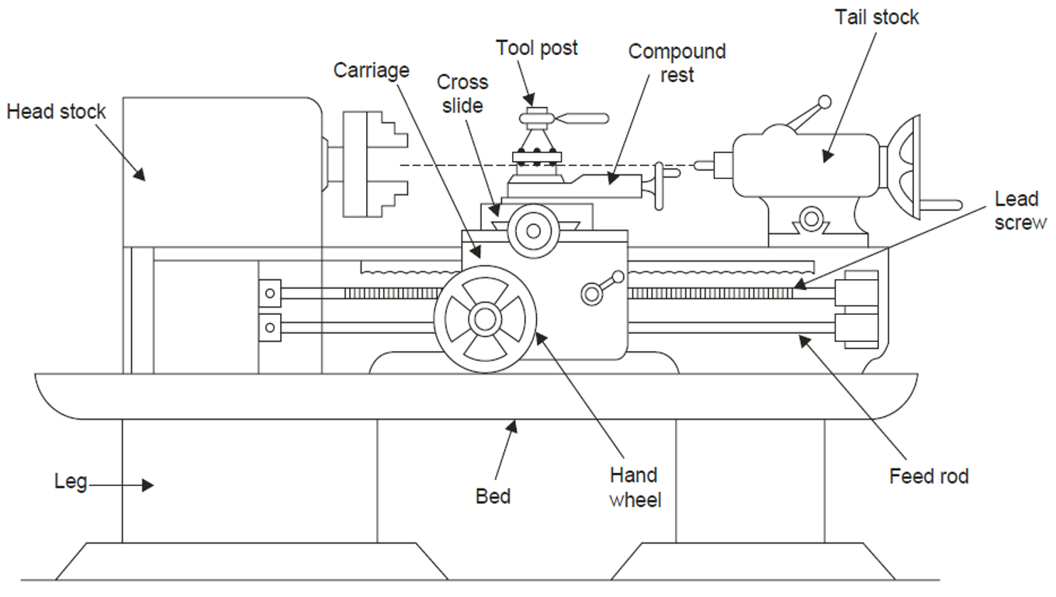

**Lathe Machine**

**BENCH LATHE**

This is a small lathe usually mounted on a bench. It has practically all the parts of an engine lathe or speed lathe and it performs almost all the operations. This is used for small and precision work.

**TOOL ROOM LATHE**

This lathe has features similar to an engine lathe but it is much more accurately built. It has a wide range of spindle speeds ranging from a very low to a quite high speed up to2500 rpm. This lathe is mainly used for precision work on tools, dies, gauges and in machining work where accuracy is needed.

**CAPSTAN AND TURRET LATHE**

The development of these 1athes results from the technological advancement of the engine lathe and these are vastly used for mass production work. The feature of this type of lathe is that the tailstock of an engine lathe is replaced by a hexagonal turret, on the face of which multiple tools may be fitted and fed into the work in proper sequence. Due to this arrangement, several different types of operations can be done on a job without re-setting of work or tools, and a number of identical parts can be produced in the minimum time.

**SPECIAL PURPOSE LATHES**

These lathes are constructed for special purposes and for jobs, which cannot be accommodated or conveniently machined on a standard lathe. The wheel lathe is made for finishing the journals and turning the tread on railroad car and locomotive wheels. The gap bed lathe, in which a section of the bed adjacent to the headstock is removable, is used to swing extra-large-diameter pieces. The T-lathe is used for machining of rotors for jet engines. The bed of this lathe has T-shape. Duplicating lathe is one for duplicating the shape of a flat or round template on to the job.

**AUTOMATIC LATHES**

These lathes are so designed that all the working and job handling movements of the complete manufacturing process for a job are done automatically. These are high speed, heavy duty, mass production lathes with complete automatic control.

**CONSTRUCTION OF LATHE MACHINE**

A simple lathe comprises of a bed made of grey cast iron on which headstock, tailstock, carriage and other components of lathe are mounted. The major parts of lathe machine are given as under

1. Bed 2.Head stock
2. Tailstock Carriage 4.Feed mechanism
3. Thread cutting mechanism

**BED**

The bed of a lathe machine is the base on which all other parts of lathe are mounted. It is massive and rigid single piece casting made to support other active parts of lathe. On left end of the bed, headstock of lathe machine is located while on right side tailstock is

located. The carriage of the machine rests over the bed and slides on it. On the top of the bed there are two sets of guide ways-inner ways and outer ways. The inner ways provide sliding surfaces for the tailstock and the outer ways for the carriage. The guide ways of the lathe bed may be flat and inverted V shape. Generally cast iron alloyed with nickel and chromium material is used for manufacturing of the lathe bed.

**HEAD STOCK**

The main function of headstock is to transmit power to the different parts of a lathe. It comprises of the headstock casting to accommodate all the parts within it including gear train arrangement. The main spindle is adjusted in it, which possesses live centre to which the work can be attached. It supports the work and revolves with the work, fitted into the main spindle of the headstock. The cone pulley is also attached with this arrangement, which is used to get various spindle speed through electric motor. The back gear arrangement is used for obtaining a wide range of slower speeds. Some gears called change wheels are used to produce different velocity ratio required for thread cutting.

**Tail Stock**

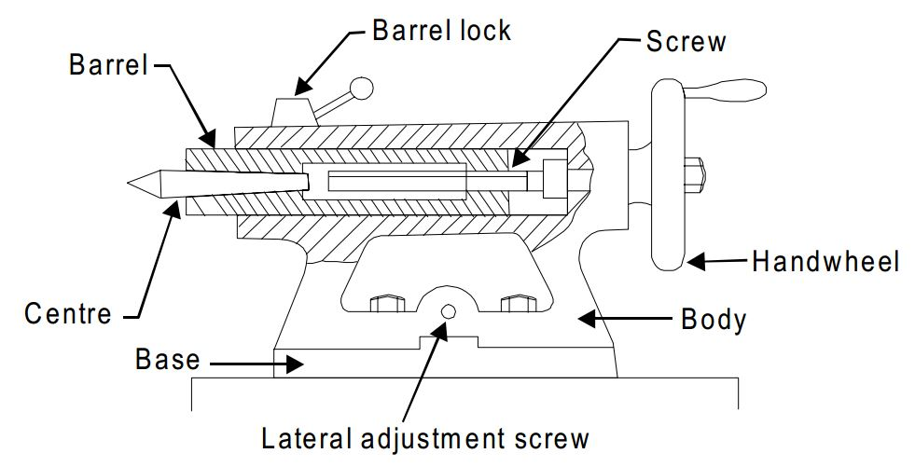

The diagram shows the tail stock of central lathe, which is commonly used for the objective of primarily giving an outer bearing and support the circular job being turned on centers. Tail stock can be easily set or adjusted for alignment or non-alignment with respect to the spindle centre and carries a centre called dead centre for supporting one end of the work. Both live and dead centers have 60° conical points to fit centre holes in the circular job, the other end tapering to allow for good fitting into the spindles.

The dead centre can be mounted in ball bearing so that it rotates with the job avoiding friction of the job with dead centre as it important to hold heavy jobs.

**CARRIAGE**

Carriage is mounted on the outer guide ways of lathe bed and it can move in a direction parallel to the spindle axis. It comprises of important parts such as apron, cross-slide, saddle, compound rest, and tool post. The lower part of the carriage is termed the apron in which there are gears to constitute apron mechanism for adjusting the direction of the feed using clutch mechanism and the split half nut for automatic feed. The cross-slide is basically mounted on the carriage, which generally travels at right angles to the spindle axis.

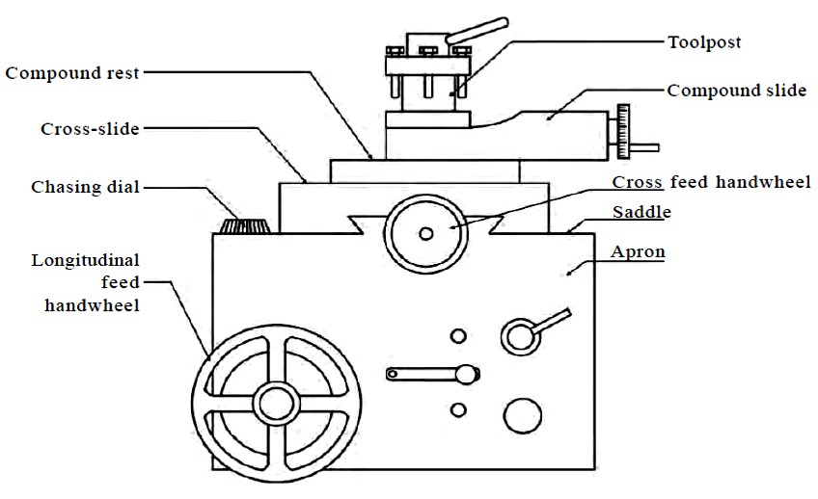

**FEED MECHANISM**

Feed mechanism is the combination of different units through which motion of headstock spindle is transmitted to the carriage of lathe machine

Following units play role in feed mechanism of a lathe machine

1. End of bed gearing
2. Feed Gear Box
3. Lead Screw and feed rod
4. Apron Mechanism

The gearing at the end of bed transmits the rotary motion of headstock spindle to the feed gear box. Through the feed gear box the motion is further transmitted either to the feed shaft or lead screw, depending on whether the lathe machine is being used for plain turning or screw cutting.

The feed gear box contains a number of different sizes of gears. The feed gear box provides a means to alter the rate of feed, and the ration between revolutions of the headstock spindle and the movement of carriage for thread cutting by changing the speed of rotation of the feed rod or lead screw. The apron is fitted to the saddle. It contains gears and clutches to transmit motion from the feed rod to the carriage, and the half nut which engages with the lead screw during cutting threads.

**VARIOUS LATHE OPERATIONS**

**1. KNURLING**

**Knurling** is a manufacturing process, typically conducted on a [lathe](https://en.wikipedia.org/wiki/Lathe_(metal)), whereby a pattern of straight, angled or crossed lines is rolled into the material. The operation is performed for producing indentations on a part of a work piece. Knurling allows hands or fingers to get a better grip on the knurled object than would be provided by the originally smooth metal surface. Occasionally, the knurled pattern is a series of straight ridges or a [helix](https://en.wikipedia.org/wiki/Helix) of "straight" ridges rather than the more-usual criss-cross pattern.

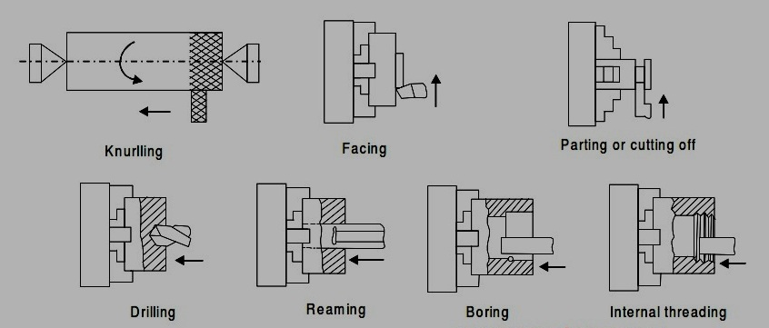

Various Lathe Operations

**2. FACING**

**Facing is the process of removing metal from the end of a work piece to produce a flat surface. Most often, the work piece is cylindrical, but**[using a 4-jaw chuck](http://www.mini-lathe.com/Mini_lathe/Chucks/4_jaw/4-Jaw.htm#Non-cylinder)**you can face rectangular or odd-shaped work to form cubes and other non-cylindrical shapes.**

**When a lathe cutting tool removes metal it applies considerable tangential (i.e. lateral or sideways) force to the work piece. To safely perform a facing operation the end of the work piece must be positioned close to the jaws of the chuck. The work piece should not extend more than 2-3 times its diameter from the chuck jaws unless a**[steady rest](http://www.mini-lathe.com/Mini_lathe/Accessories/accessories.htm#Steady_Rest)**is used to support the free end.**

**3. DRILLING AND REAMING**

Drilling is a process of producing round holes in a solid material or enlarging existing holes with the use of multi tooth cutting tools called drills or drill bits. Various cutting tools are available for drilling, but the most common is the twist drill.

Reaming is a process of improving the quality of already drilled holes by means of cutting tools called reamers. Drilling and reaming are performed on a drilling press, although other machine tools can also perform this operation, for instance lathes, milling machines, machining centres. In drilling and reaming, the primary motion is the rotation of the cutting tool held in the spindle. Drills and reamers execute also the secondary feed motion. Some finishing reaming operations are manual.

**4. BORING**

In [machining](https://en.wikipedia.org/wiki/Machining), boring is the process of enlarging a hole that has already been [drilled](https://en.wikipedia.org/wiki/Drill) (or [cast](https://en.wikipedia.org/wiki/Casting)) by means of a [single-point cutting tool](https://en.wikipedia.org/wiki/Tool_bit) (or of a boring head containing several such tools), such as in boring a [gun barrel](https://en.wikipedia.org/wiki/Gun_barrel) or an [engine cylinder](https://en.wikipedia.org/wiki/Cylinder_(engine)). Boring is used to achieve greater accuracy of the diameter of a hole, and can be used to cut a tapered hole. Boring can be viewed as the internal-diameter counterpart to [turning](https://en.wikipedia.org/wiki/Turning), which cuts external diameters.

There are various types of boring. The boring bar may be supported on both ends (which only works if the existing hole is a through hole), or it may be supported at one end (which works for both through holes and [blind holes](https://en.wikipedia.org/wiki/Blind_hole)). Line boring (line boring, line-boring) implies the former. Back boring (back boring, back-boring) is the process of reaching through an existing hole and then boring on the "back" side of the work piece (relative to the machine headstock).

**5. THREADING**

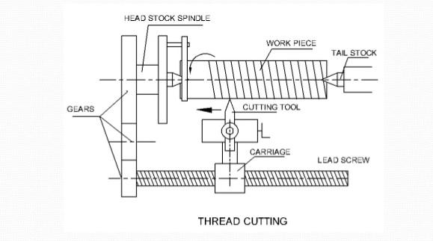

A thread is a uniform helical groove cut inside a cylindrical work piece or on the outside of a tube or shaft. Principle of thread cutting is to produce a helical groove on a cylindrical or conical surface ¬ by feeding tool longitudinally when job is revolved between centres or by a chuck ¬ longitudinal feed should be equal to the pitch of the thread to be cut per revolution of the work piece ¬ lead screw through saddle receives traversing motion, has a definite pitch.

**EXTERNAL THREAD CUTTING**

* First step is to remove the excess material from the work piece to make its diameter equal to the major diameter of thread
* Change gears of correct size are fitted to the end of the bed between the spindle and the lead screw
* Shape or form of the thread depends on the shape of the cutting tool to be used thread cutting.
* In a metric thread, the included angle of the cutting edge should be ground exactly 60°
* Top of the tool nose should be set at the centre of the work piece.
* Angle gauge is usually used against the turned surface
* Speed of the spindle is reduced by one half to one fourth of the speed required for turning
* Half-nut is then engaged
* Depth of cut, which usually varies from 0.05 to 0.2 mm
* Tool has produced a helical groove up to the end of the work, quickly withdrawn by the use of the cross slide
* Half nut disengaged, and the tool is brought back to the starting position to give a fresh cut
* Before re-engaging the half nut, it is necessary to ensure that the tool will follow the same path it has traversed in the previous cut, otherwise the job will be spoiled
* Several cuts are necessary before the full depth of thread is reached.

**INTERNAL THREAD CUTTING**

Hole is first bored to the root diameter of the thread. Tool is fixed on the tool post or on the boring bar after setting it at right angles to the lathe axis, using a thread gauge/angle gauge. Depth of cut is given by the compound slide and the thread is finished in the usual.

**MACHINE SHOP VIVA QUESTIONS**

**Question** Name five parts of lathe machine.

**Answers** – Bed, Head stock, Carriage, Tail stock, Legs.

**Question**  What are machine tools used in machine shop ?

**Answers** – Surface Gauge, Drill bits, Boring bar, Dead centre, Knurling tool, Steel rule, Vernier caliper, tool Bit, In side caliper, outside caliper.

**Question** How many types of chuck ?

**Answers** – Three Jaw chuck, Four Jaw chuck, Magnetic chuck.

**Question** How many types of Lathe machines ?

**Answers** – 1. Centre lathe

2. Precision lathe

3. Tool room lathe

4. Capstan and Turret

5. Automatic lathe

6. Speed lathe

7. Engine lathe

8. Bench lathe

9. Special purpose lathe

**Question** Which operations performed on lathe machine ?

**Answers** – Facing, Turning, Shouldering, Necking, Taper Turning, Step Turning, Thread cutting(Internal & External), Forming, Chamfering, Knurling, Drilling, Boring etc.

**JOB**

**AIM** : To make the multi operation job as per given drawing by the technology process in machine shop.

**MATERIAL REQUIRED**: Mild Steel Round Bar Dia-32*93mm

**MACHINE**: Centre Lathe machine (4.5’)

**TOOLS & EQUIMENT REQUIRED**: Side and face turning tool, Knurling tool, Grooving tool, External threading tool, Centre drill.

**MEASURING INSTRUMENT:** Vernier caliper and Steel rule.

**OPERATIONS:**

1. Facing
2. Chamfering
3. Cylindrical turning
4. Step turning
5. Knurling
6. Grooving
7. Taper turning
8. Centre Drilling
9. External Threading

**(T.P.I stands for thread per inch)**

**PRECAUTION**:

1. Apply pressure for filling in forward stroke only.
2. Never touch moving parts, belts and rotating tools etc.
3. Always wear safety goggles.
4. Never wear loose clothes.
5. Always keep your eyes away from the work piece.